**PATHOLOGY**

* **Introduction to Pathology**

Pathology is a the study of diseases blood of urine. [1]The word *pathology* also refers to the study of disease in general, incorporating a wide range of biology research fields and medical practices. However, when used in the context of modern medical treatment, analysis of tissue and human  samples. Idiomatically, "a pathology" may also refer to the predicted or actual progression of particular diseases (as in the statement "the many different forms of cancer have diverse pathologies", in which case a more proper choice of word would be "pathophysiology"), and the affix *pithy* is sometimes used to indicate a state of disease in cases of both physical ailment (as in cardiomyopathy) and physiology conditions (such as psychopathy). A physician practicing pathology is called a pathology[2]

**Module No 1- Introduction to pathology blood and urine**

Pathology is the study of the causes and effects of disease or injury. The word pathology also refers to the study of disease in general, incorporating a wide range of biology research fieldsand medical practices. However, when used in the context of modern medical treatment, the terms often used in a narrower fashion to refer to processes and tests that fall within the contemporarymedical field of "general pathology", an area which includes a number of distinct but inter-related medical specialties that diagnose disease, mostly through analysis of tissue, cell, and body fluid samples. Idiomatically, "a pathology" may also refer to the predicted or actual progression of particular diseases (as in the statement "the many different forms of cancer have diverse pathologies", in which case a more proper choice of word would be Pathophysiology "), and the affix pathy is sometimes used to indicate a state of disease in cases of both physical ailment (as in cardiomyopathy) and psychological conditions (such as psychopathy).[3] A physician practicingpathology is called a pathologist.

Pathology includes the knowledge regarding the diagnosis of the disease through the different analytical techniques thatare implemented on the biological sample material and compared with standard results, it includes the examination of blood, urine and other different body fluids and whole bodies i.e. autopsies. [3]Early systematic human dissections were carried out by the Ancient Greek physicians Herophilus of Chalcedon and Erasistratus of Chios in the early part of the third century BC. The first physician known to have made postmortemdissections was the Arabian physician Avenzoar(1091–1161). Rudolf Virchow (1821–1902) is generally recognized tobe the father of microscopic pathology. Most early pathologists were also practicing physicians or surgeons.[4]In common medical practice, general pathology is mostly concerned with analyzing known clinical abnormalities thatare markers or precursors for both infectious and non-infectious disease, and is conducted by experts in one of two major specialties, anatomical pathology and clinical pathology. Further divisions in specialty exist on the basis of the involved sample types.[4]

The term pathology has its different types as general pathology, anatomic pathology, clinical pathology, forensic pathology, veterinary pathology, pathology as a medical specialty. Their are different analytical techniques for even type of diagnosis and identify the error.

As a field of general inquiry and research, pathology addresses components of disease: cause, mechanisms of development (pathogenesis), structural alterations of cells (morphologic changes), and the consequences of changes [5]

**1 Clinical Chemistry Of Blood**

Blood is one of the important body fluids which carry the nutrients and the Drug material to treat or to provide the supplies to cells Our blood is made up of liquid and solids. The liquid part called plasma, is made of water, salts, and protein. Over half of your blood is plasma. The solid part of your blood contains red blood cells, white blood cells, and platelets.[4,5]Red blood cells (RBC) deliver oxygen from your lungs to your tissues and organs. White blood cells (WBC) fight infection and are part of your immune system. Platelets help blood to clot when you have a cut or wound. Bone marrow, the spongy material inside your bones, makes new blood cells. Blood cells constantly die and your body makes new ones. Red blood cells live about 120 days, and platelets live about 6 days. Some white blood cells live less than a day, but others live much longer.[6 7]

Red blood cells (RBCs), also referred to as red cells, red blood corpuscles (in humans orother animals not havingnucleus in red blood cells), haematids, erythroid cells or erythrocytes(from Greek erythros for "red" and kytos for hollow vessel", with -cyte translated as "cell" unmodern usage), are the most common type of blood cell and the vertebrates principal means of delivering oxygen (O2) to the body tissues—via blood flow through the circulatory system .RBCstake up oxygen in the lungs, or in fish the gills, and release it into tissues while squeezing through the body’s capillaries. RBC's cytoplasm is reach of hemoglobin the hemoglobin is the componantwhich play major function of the RBC that is transport of gases from lungs to body and body to lungs. When it carrying oxygen form the lungs to body it known as the "oxyhemoglobin", and when it carrying carbon dioxide from body parts to the lungs for purification they know as"carboxyhemoglobin". Each human RBC contain approximately 270 million hemoglobin’s.[6 7]

There are four blood types

four blood types: A, B, AB, or O. Also, blood is either Rh-positive or Rh-negative. So if you have type A blood, it's either A positive or A negative. Which type you are is important if you need a blood transfusion. And your Rh factor could be important if you become pregnant an incompatibility between your type and the baby's could create problems. Blood tests such as blood count tests help doctors check for certain diseases and conditions. They also help check the function of your organs and show how well treatments are working. Problems with your blood may include bleeding disorders, excessive clotting and platelet disorders. If you lose too much blood, you may need a transfusion. Also the life threatening disease like blood cancer can be determined by Pathology studies.[6 7]

**2 Erythrocytes – Abnormal cells and their Significance**

Erythrocytes are nothing but RBC'S these are the major component of the body around 40to 45% of erythrocytes is their inside the blood, A type of blood cell that is made in the bone marrow and found in the blood. Erythrocytes contain a protein called hemoglobin, which carries oxygen from the lungs to all parts of the body. Checking the number of erythrocytes in the bloodies usually part of a complete blood cell (CBC) test. It may be used to look for conditions such as anemia, dehydration, malnutrition, and leukemia. Also called RBC and red blood cell. If their is variation in no.Of the erythrocytes in the CBC test report then it shows different physiological changes in body.[8]

A red blood cell (RBC) count is typically done as part of a complete blood count. This is a screening test to check for a variety of medical conditions. We need to take these CBS testing on Specific duration of time to avoid certain look for specific health problems, such as internal bleeding, anemia, kidney disease, and certain cancers. You may also need this test if your healthcare provider wants to watch any of these health problems. Your healthcare provider may also want this test donator determine if your RBC count is too high. A red blood cell count is often part of a complete blood count (CBC). This means that other components of blood are also measured. These include white blood cells, your hemoglobin level and platelets.[8]If healthcare provider suspects that you have a particular illness, they may also order other tests needed for making a diagnosis An RBC count is measured in millions per cubic millimeter (million/mm3). Normal values may vary slightly among different labs

One example of normal values is:

3.6 to 5 million/mm3 for female

4.2 to 5.4 million/mm3 for males[8]

When a pathogen invades the human body, it infects the blood and organs, causing infection and sepsis-related symptoms. Pathogens change the internal environment, increasing the levels of reactive oxygen species, influencing erythrocyte morphology, and causing erythrocyte death, i.e., eryptosis. Characteristics of eryptosis include cell shrinkage, membrane blebbing, and surface exposure of phosphatidylserine (PS). Eryptotic erythrocytes increase immune cell proliferation, and through PS, attract macrophages that remove the infected erythrocytes. Erythrocyte-degraded hemoglobin derivatives and hemi deteriorate infection; however, they could also be metabolized to a series of derivatives. The result that erythrocytes play an anti- infection role during sepsis provides new mo for treatmentwhich causes erythrocyte shrinkage, membrane blebbing, and phosphatidylserine (PS) exposure, resulting in degrade and reduced amounts of erythrocytes, thereby inducing anemiainmorphology indicate multiple protruding spikes on the surface during septic shock and RBCaggregation. In vivo studies revealed similar results; in mouse models of cercal ligation and puncture (CLP)-induced sepsis, plasma-derived extracellular vesicles (EVs) increase RBC rigidity and influence RBC deformability. In rat models of CLP-induced sepsis, oxidative stress alters the rheology of blood-influenced RBC deformability[8] follimshowing the different size and shape of :

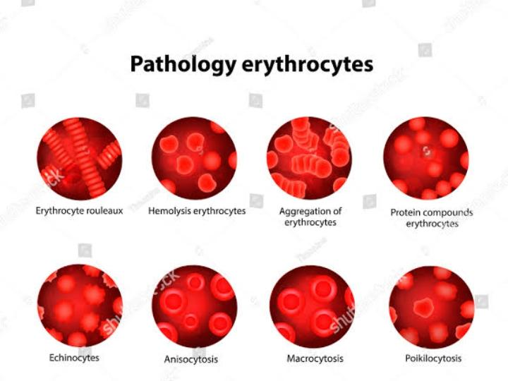

**i Sickle cell anemia:** Abnormal hemoglobin in erythrocytes causes them to take on a sickle shape, leading to reduced oxygen-carrying capacity and potential blockage of blood vessels.

**ii Thalassemia:** Genetic disorders affecting hemoglobin production can result in abnormal erythrocytes, causing anemia and impacting overall oxygen transport.

**iiiAnisocytosis:** Variation in erythrocyte size may indicate underlying health issues, such as nutritional deficiencies or certain diseases.

**ivPoikilocytosis:** Irregular erythrocyte shapes can be a sign of disorders like elliptocytosis or spur cell anemia, affecting their function and longevity.

**3 Anemia**

It is the disease conditions in which their is less no of the erythrocytes then that of the normal count Anemia is defined by WHO by a hemoglobin level that is less than 13 g/dL in male adults, and less than 12 g/dL in female adults. This definition is the most commonly used one in both clinical and research settings. Anemia will lead to decreased capacity of RBCs to carry oxygen, eventually causing significant morbidities and mortalities. Anemia presents initially with non- specific symptoms like fatigue, weakness, or even impaired cognitive functions. Elderly with anemia are at a higher risk of hospitalization with higher mortality rates. Anemia can be presenting up to 17% of congestive heart failure cases worsening capacity and survival significantly. In children anemia has been shown to cause a decline in psychomotor and cognitive development. Moreover, the risks of preterm labor, low birth weight, and maternal mortality, were all found to significantly increase with the presence of iron deficiency [9 10]. To summarize, children,

young women, pregnant women, and elderly have the highest risk of morbidity and mortality associated with anemia. Other important factors include racial and ethnic disparities; African Americans have a 3-fold increase in the prevalence of anemia when compared to whites. The most important cause of anemia is iron deficiency. However, chronic diseases and other causes that lead to decreased RBCs count, have been dramatically increasing lately.[9. 10]

Anemia is usually subdivided according to it pathophysiology into: insufficient production, or bleeding/hemolysis causing loss of RBCs. Therefore, the main two types of anemia are hypo regenerative and regenerative. In hypo regenerative anemia, there is impaired bone marrow functions that cause decreased production of precursor This can occur due to abnormal infiltration of bone marrow or malnutrition. On the other hand, regenerative anemia involves proper response of bone marrow to the decrease of RBCs by a compensatory increase in production.[9 10] There are different types if anemia classified on basis of their causes as the anemia due to deficiency of nutritional supplies known as nutritional anemia, deficiency of the folic acid and another one type is their i.e. due to deficiency of cobalamin the disease and their treatment are discussed below.[9 10]

Treatment for nutritional deficiency anemia Normal blood counts can normally be achieved following a regimen of oral iron for eight weeks. However, it is recommended to keep patients on treatment for several months later, as this will replenish body stores of iron, and will lead to significantly decrease in recurrence rates. Intravenous iron is preserved for severe cases or cases with continuous blood loss, noncompliance, or malabsorption. It is also essential to correct the underlying cause of iron deficiency. When it comes to cobalamin deficiency treatment, eight weeks are usually enough for anemia to resolve.

However, it is essential to periodically administrate vitamin B12 injections to prevent recurrence especially in cases of malabsorption. Irreversible cases will require lifelong therapy. Oral vitamin B12 is not associated with good outcomes due to low bioavailability. [9. 10] When folic acid deficiency is confirmed, treatment will mainly depend on oral supplementation which has a relatively high bioavailability. It also essential to consider alcoholism and malabsorption as possible etiologies, as nutritional folic acid deficiency is very rare. When oral folic supplementation fails, raise the doses or give folic acid injections. Before administrating folic acid by any route, cobalamin deficiency must be ruled out. Otherwise, severe exacerbation of neurological manifestation may occur.

**4 Disorder of WBCs**

White blood cell disorders can involve quantitative or qualitative abnormalities in these immune cells. Some examples include:

1. **Leukocytosis:** An increase in the total number of white blood cells (WBCs). This can be caused by infections, inflammation, leukemia, or stress.
2. **Leukopenia:** A decrease in the number of white blood cells, making the body more susceptible to infections. Causes may include viral infections, certain medications, or bone marrow disorders.
3. **Neutropenia:** A specific type of leukopenia characterized by a low number of neutrophils, a type of white blood cell crucial for fighting bacterial infections.
4. **Neutrophilic:** An elevated level of neutrophils, often seen in response to bacterial infections, inflammation, or stress.
5. **Lymphocytosis:** An increase in the number of lymphocytes, often seen in viral infections and some chronic diseases.

**5 Lymphocytes and platelets their roles in health and disease**

**Lymphocytes**

Lymphocytes are a type of white blood cell. They help your body’s immune system fight cancer and foreign viruses and bacteria. Your lymphocyte count can be taken during a normal blood test at your healthcare provider’s office. T, B, and NK cells and their respective subsets (Table I) originate from the bone marrow– derived progenitors. Progenitors that migrate to the thymus and receive signals through the Notch receptor commit to the T-cell lineage.1 In human beings, lineage development is critically dependent on IL-7 for T cells2 and IL-15 for NK cells.3 Lymphocyte specificity and diversity are gained during the process of T-cell receptor (TCR) or B-cell receptor (BCR) generation, key events in the adaptive immune. [11 12] Lymphocyte levels vary depending on your age, race, sex, altitude and lifestyle.

A type of immune cell that is made in the bone marrow and is found in the blood and in lymph tissue. The two main types of lymphocytes are B lymphocytes and T lymphocytes. B lymphocytes make antibodies, and T lymphocytes help kill tumor cells and help control immune responses. A lymphocyte is a type of white blood cell.[11 12]

There are two main types of lymphocytes::

• T lymphocytes (T cells): T cells control your body’s immune system response and directly attack and kill infected cells and tumor cells.

• B lymphocytes (B cells): B cells make antibodies. Antibodies are proteins that target viruses, bacteria and other foreign invaders

**Role of lymphocytes**

Lymphocytes help your body’s immune system fight cancer and foreign viruses and bacteria (antigens). Lymphocytes help your immune system remember every antigen it comes in contact with. After an encounter, some lymphocytes turn memory cells. When memory cells run into an antigen again, they recognize it and quickly respond. This is why you don’t get infections like measles or chickenpox more than once. It’s also the reason getting vaccinated can prevent certain disease [13,14]

**Platelets**

Platelets are tiny blood cells that help your body form clots to stop bleeding. If one of your blood vessels gets damaged, it sends out signals to the platelets. The platelets then rush to the site of damage and form a plug (clot) to fix the damage.

The process of spreading across the surface of a damaged blood vessel to stop bleeding is called adhesion. This is because when platelets get to the site of the injury, they grow sticky tentacles that help them stick (adhere) to one another. They also send out chemical signals to attract more platelets. The additional platelets pile onto the clot in a process called aggregation.[15 ] Under a microscope, a platelet looks like a tiny plate. Your healthcare provider may do a blood test called a complete blood count to find out if your bone marrow is making the right number of platelets.[16]

**Role of platelets**

Platelets have two primary roles:

1. **Clotting:** They help prevent excessive bleeding by forming blood clots at the site of injury.
2. **Wound Healing:** Platelets release growth factors that contribute to the healing process, attracting other cells involved in tissue repair.

**3 Role of the hemostasis**

**4 Vasoconstriction**

**5Temporory hemostatic plug**

**6 Definitive hemostatic plug**

**7 Role of clot formation**

**8 Role of clot retraction**

**9 Role in repair of injured bloods**

**10 Transport and storage function**

**ADP and Thromboxane A2**

**Module-3 Introduction to light microscopy**

**Although the light microscope remain to central modern biomedical sciences, light Microscopy is often regarded as an old technique. While light microscopy is indeed over 400years old, the technique continues to evolve and its full potential in the biomedical sciences may not yet be fully realized. The purpose of light microscopy is to provide magnified images of specimens illuminated or emitting light in the visible range of the spectrum, or that of the adjacent ultraviolet or near- infrared regions of the spectrum. Optical magnification is achieved by passing light through lenses. With modern digital imaging technologies, a digital photomicrograph can be easily magnified. After a certain point, magnification reveals no further details and the image becomes highly pixelated. This shows that magnification has increased without increasing the resolution. This is a simplistic illustration of how resolution is more important than magnification in most of the applications. A light microscope is a biology laboratory instrument or tool, that uses visible light to detect and magnify very small objects and enlarge them. They use lenses to focus light on the specimen, magnifying it thus producing an image. The specimen is normally placed close to the microscopic lens.[17] Microscopic magnification varies greatly depending on the types and number of lenses that make up the microscope. Depending on the number of lenses, there are two types of microscopes i. e Simple light microscope (it has low magnification because it uses a single lens)and the Compound light microscope (it has a higher magnification compared to the simple microscope because it uses at least two sets of lenses, an objective lens, and an eyepiece). The lenses are aligned in that, they can be able to bend light for efficient magnification of the image.[17] viewed by passing it through one or two lenses The transparency of the specimen allows easy and quick penetration of light .specimen can be vary form bacterial to a cells and other microbial particles .**

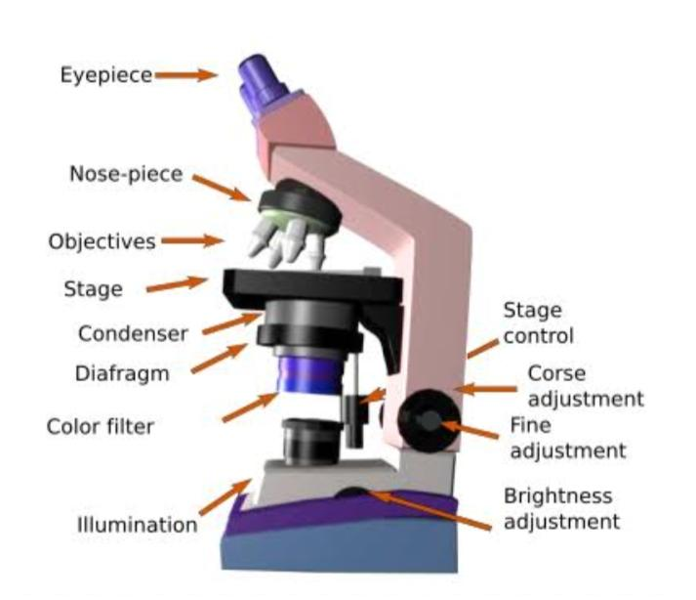 **Principal of light microscopy**

As mentioned earlier, light microscopes visualize an image and it uses a glass lens, and magnification is determined by, the ability of lenses to bend light and focus it on the specimen, it results in formation an image. When a ray of light passes through one medium into another, the ray bends at the interface causing refraction. The refractive index is used to determine bending of light, which is a measure of how great a substance slows the speed of light. The refractive indexes of the two mediums that form the interface, the direction and magnitude of bending of the light are determined.[17]

**Different types of light compound microscope**

There are different types of light Microscope are used as they are of two types i.e. Simple light Microscope and Compound light Microscope where as in simple light Microscope only one lens is used and in compound light microscope two or more lenses used .

Types of light Microscope

• Bright field Light Microscope

• Phase Contrast Light Microscope

• Dark-Field Light Microscope

• Fluorescence Light Microscope

Bright field Microscope:

It is type of the most basic optical Microscope used in microbiology laboratories in this laboratory the dark image against bright background is produced. It is of two lenses, and widely used to view plant and animal cell organelles and also it includes parasites such as Paramecium by staining with basic stains. Its functionality is based on to provide a high-resolution image, which fully depends on the perfect use of the microscope. This means that an sufficient amount of light will enable sufficient focusing of the image, to give a quality image. It is also known as a compound light microscope.[17] Phase contrast light Microscope: This is a type of optical microscope in this small light deviations known as phase shifts takes place during light penetration into the unstained specimen. These phase shifts are get converted into the image to mean, when light passes through the opaque specimen, the phase shifts brighten and the specimen forming an illuminated (bright) image in the background.[17]

The principle behind the working of the phase-contrast microscope is based on the use of an optical method of transform a specimen into an amplitude image, that’s can be viewed by the eyepiece of the microscope which locates at upper side of Microscope.

natural state, at a high contrast and efficient clarity. This is done because if the specimens are stained and fixed, they kill most cells, it is a characteristic that is uniquely undone with the bright field light microscope Dark-Field Light Microscope This is a specialized type of bright field light microscope it has several similarities towards the Phase-Contrast Microscope. For making of a dark field Microscope, place a dark field stop underneath and a condenser lens which produces a hollow cone beam of light, the beam of lighteners the objective only, from the specimen.[17 18] This technique is used to visualize the living unstained cells. This is affected by the way illumination is done on the specimen in that, when a hollow cone beam of light is transmitted to the specimen, deviated light (reflected/refracted) light passes through the objectives and it results to the specimen forming an image.[17 18]

This makes the surrounding field of the specimen appear black while Their the specimen will appear illuminated. This is enabled by the dark background this the name, dark-field Microscopy. The Fluorescent Microscope The above-discussed microscopes will normally produce images after a light has been transmitted and passed through the specimen. In the case of the fluorescent Microscope, the specimen emits light. How? By adding a dye molecule to the specimen. This dye molecule will normally become excited when it absorbs light energy, hence it releases any trapped energy as light. The light energy that is released by the excited molecule has a long wavelength compared to its radiating light. The dye molecule is normally a fluorophore, that fluoresces when exposed to the light of a certain specific wavelength. The image formed is a fluorophore-labeled image from the emitted light.[17 18]

The principle behind this working mechanism is that the fluorescent microscope will expose the specimen to ultra or violet or blue light, which forms an image of the specimen that is emanated by the fluorescent light. They have a mercury vapor arc lamp that produces an intense beam of light that passes through an exciter filter. The exciter filter functions to transmit a specific wavelength to the fluorochrome stained specimen, producing the fluorochrome- labeled image, at the objective [17 18]

**Module-4 Experimental**

1. **Introduction to semi- auto analyzer**

A -auto analyzer is a laboratory instrument designed to partially automate the process of chemical analysis. Unlike fully automated analyzers, which handle the entire analysis without human intervention, semi-auto analyzers require some manual steps. These instruments are commonly used in clinical laboratories to perform various tests, such as blood chemistry analysis. Users typically load samples and reagents manually, while the analyzer automates certain steps like mixing, incubation, and measurement, streamlining the analytical workflow.

**Advantages**

Requires less quantity of reagent & sample. Hence

economical.

◻ Calibration facility, calibration data storage

◻Enzyme determination by kinetic method confirmed accurately

◻ Data storage data transfer to external compute printer etc are available

◻ Tests are programmed in advance & hence are

automatically selected.

◻ Automated calculation of results.

◻ Use of non corrosive & monostep reagents

**Disadvantages**

Sample & reagent requirement is more than fully automated

analyzer

◻ Multistep calibration not feasible

◻ Limited data storage facility

◻ Time consuming

◻ Lot of human intervention & hence more errors

◻ Works as an batch analyzer & not an random axis.

◻ Difficult to process stat samples

◻ Limited capacity to handle workload

◻ Auto dilution facility not available

◻ QC data analysis i.e. LJ charts, Westgard multirule applications not available requirements

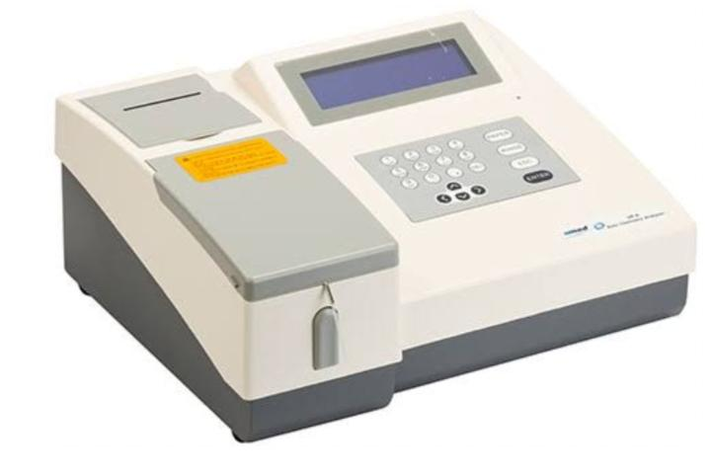

**Semi auto analyzer**

**2 Various test performed using Semiauto analyzer** - semi auto analyzer are used to perform various diagnostic tests in a semi-automated manner. Common tests include blood chemistry profiles, enzyme assays, and immunoassays. These devices streamline the testing process while allowing some manual intervention. Examples of tests include glucose levels, liver function tests, and hormone assays. Specific tests depend on the analyzer and its capabilities.

1. **Blood Chemistry Tests:**
   * Glucose levels
   * Cholesterol levels
   * Electrolyte levels (sodium, potassium, etc.)
   * Kidney function tests (creatinine, blood urea nitrogen)
2. **Liver Function Tests:**
   * Alanine aminotransferase (ALT)
   * Aspartate aminotransferase (AST)
   * Alkaline phosphatase (ALP)
   * Bilirubin levels
3. **Enzyme Assays:**
   * Amylase
   * Lipase
4. **Immunoassays:**
   * Hormone assays (thyroid hormones, reproductive hormones)
   * Tumor markers
   * Cardiac markers (troponin, creatine kinase-MB)
5. **Specialized Tests:**
   * Coagulation tests (PT, APTT)
   * Blood gas analysis
   * Drugs and toxicology screening

**Module -5 Analysis of constituents blood and urine**

These include urea, uric acid, and creatinine. The abnormal constituents of urine are blood cells, albumin, and glucose. Presence of albumin, glucose, and blood cells in the urine causes the pathological conditions called albuminuria, glycosuria, and hematuria respectively.

**Analysis of normal and abnormal constituents of blood and urine**

The kidneys remove waste product from the blood through small filtering units called nephrons.

• Each nephron consists of a ball of small blood capillaries, called a glomerulus, and a small tube called a renal tubule.

• The kidneys form urine, which passes through the ureters to the bladder for storage prior to

excretion

• Waste product of protein metabolism are excreted, electrolyte levels are controlled and pH (acid-base balance) is maintained by excretion of H+ ions.

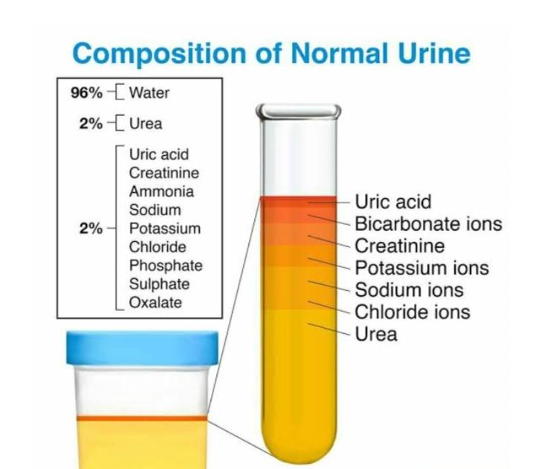**Normal constituents blood and urin**

**Urea: Nitrogenous Constituents:**

**1.** Urea is the main end product of catabolism of protein in mammals. Its excretion is directly proportional to the

protein intake. It consists of 80-90% of the total urinary nitrogen.

2 In fever, diabetes, or excess adrenocortical activity, urea excretion is increased due to increased protein catabolism

3 Decreased urea excretion is due to decreased urea production in the last stages of fatal liver disease.

4 In acidosis, there is decreased urea excretion.[19 20]]

**Ammonia**:

1. Ammonia is formed by the kidney from glutamine or amino acids in acidosis.

2. There is a high ammonia output in the urine in uncontrolled diabetes mellitus in which renal function is

unimpaired.

**Creatinine**

1. Creatine is excreted by children and pregnant women and much smaller amounts in men. Theexcretion in men

is 6% of the total excretion of creatinine.

2. Creatinine is formed from creatine. It is excreted in relatively constant amounts regardless of diet.

3. The creatinine coefficient is the ratio between the amount of creatinine excreted in 24 hours and the body

weight in kg. It is usually 20-26 mg/kg/day in normal men and 14-22 mg/kg/day in normal women.

4. Creatinine excretion is decreased in many pathological conditions.

5. Creatine excretion is also found in pathological states such as starvation, hyperthyroidism, impaired

carbohydrate metabolism and infections.

6. Creatine excretion is decreased in hypothyroidism.[19 20]

**Uric Acid**:

1. It is the end product of the oxidation of purines in the body. It is not only formed from dietarynucleoprotin but also form the breakdown of cellular nucleoprotein in body
2. It is slightly soluble in water and precipitates readily from acid urine on standing.

3. Uric acid excretion is increased in leukemia, severe liver disease and various stages of gout

4The concentrated urine on cooling forms a brick-red deposit which is mainly acid urate

5. Pure uric acid is colourless. Deposits of uric acid and urates are coloured by absorbed urinary pigments,

particularly the red uroervthrin.

6. The specificity of the analysis of uric acid is increased by treatment with uricase, the enzyme (fromhog kidney)

which converts uric acid to allantoin.[19 20]

**Amino Acids:**

1. About 150-200 mg of amino acid nitro•gen is excreted in the urine of adults in 24 hours.

2. The infant at birth excretes about 3 mg amino acid nitrogen per pound of body weight, and up to the age of 6

1. the value reaches to 1 mg/pound which is maintained throughout childhood. Prema•tureinfants excrete
2. 10 times amino acid nitrogen than that of full-term infant.
3. 3. The low excretion of amino acid nitrogen is due to its high renal threshold value.
4. 4. Increased amounts of amino acids are excreted in liver disease and in certain types of poisoning.
5. 5. In cystinuria, 4 amino acids-arginine, cystine, lysine and ornithine are excreted in urine.[19 20]

**Allantoin**:

1. It is the partial oxidative products of uric acid. Small quantities of the allantoin are excreted in humanurine.

2. In other sub-primate mammals, allantoin, the principal end product of purine metabolism, isexcreted.[19 20]

**Sulphates**:

1. The urine sulphur is derived from sulphur containing amino acids such as methionine and cystontaining amino acids such as methionine and cystine and therefore,It’s output varies with protein intake.

**Abnormal constituent of urine**

**Urinalysis**

Urinalysis (UA) simply means analysis of urine, it is a laboratory test done to detect problems with your body that can

appear in your urine.

The abnormal constituents found in urine are as follows Abnormal Constituents

• Proteins

• Sugar(Glucose & others)

• Ketone bodies

• Bile salts

• Bile pigments

• Blood[17,18]

**Blood**

In the lesion of kidney or urinary tract blood is excreted in the urine.

Free haemoglobin is also found in urine after quick hemolysis e.g. in black water fever( a complication of malaria) or after severe burns [17,18]

**Abnormal Conditions of blood**

Hematourea - when 5 or more intact RBCs/HPF.

**Symptoms**:

* Renal Neoplasms
* TB
* Kidney disease
* Fatigue
* Weakness
* Dizziness
* Headache
* Shortness of breath
* Chest pain
* Coldness in hands

**Module 6 Report analysis**

Analyzing a pathology report involves a detailed examination of diagnostic findings related to diseases or conditions. Here's a guide:

**Analyzing pathology report laboratory diagnosis of disease**

1. **Review Patient Information:** Start by reviewing patient demographics, medical history, and any relevant clinical information provided in the report.
2. **Understand Specimen Details:** Examine details about the specimen, including its type, source, and any specific characteristics noted during collection.
3. **Evaluate Macroscopic Description:** If applicable, assess the macroscopic description of the specimen, such as its size, color, and other visible features.
4. **Microscopic Examination:** Focus on microscopic findings. This includes the examination of cells, tissues, or other structures under a microscope. Pay attention to cell morphology, architecture, and any abnormalities.
5. **Diagnostic Tests:** Identify and evaluate the results of any diagnostic tests performed, such as immunohistochemistry, molecular tests, or special stains. Understand their implications for the diagnosis.
6. **Diagnosis and Interpretation:** Analyze the pathology diagnosis provided. Understand the interpretation of findings and how they relate to the patient's condition.
7. **Grading and Staging (if applicable):** If the report involves cancer, pay attention to grading and staging information. Grading reflects the aggressiveness of cancer cells, while staging indicates the extent of disease spread.
8. **Consider Differential Diagnoses:** Evaluate if the report discusses alternative diagnoses or considerations. Pathologists may provide insights into possible differential diagnoses based on the findings.
9. **Check for Consistency:** Ensure that all information in the report is consistent and logically presented. Verify that the conclusions align with the observed pathology.
10. **Consult Pathologist's Notes:** If available, read any additional notes or comments provided by the pathologist. These may offer insights, clarifications, or recommendations.
11. **Correlation with Clinical Information:** Correlate pathology findings with the patient's clinical history. Understanding how the pathology aligns with the broader clinical picture helps in providing comprehensive insights.
12. **Limitations:** Be aware of any limitations mentioned in the report, such as challenges in sample quality or interpretation difficulties. Understanding these limitations is essential for a nuanced interpretation.
13. **Summarize Key Points:** Summarize the key pathology findings and their clinical implications. Clearly articulate the significant aspects of the report that may influence patient management.